Exam 23

Problem 1
a.
I write it up in matrix form E has 4 strategies I has 2
$$E:(out,f)(out,a)(in,f)(in,a)$$
$$I:F,A$$
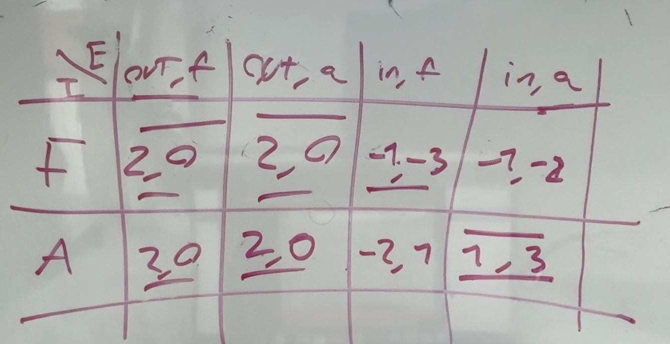
This gives the following matrix after having done the best response method we get 3
NE:$\left(\left(out,f\right),F\right) \left(\left(out,a\right),F\right) (\left(in,a\right),A)$

b.which of these are subgame perfect?
I start by setting up the subgame in the ”in” state to see which NE are NE are also NE in this state
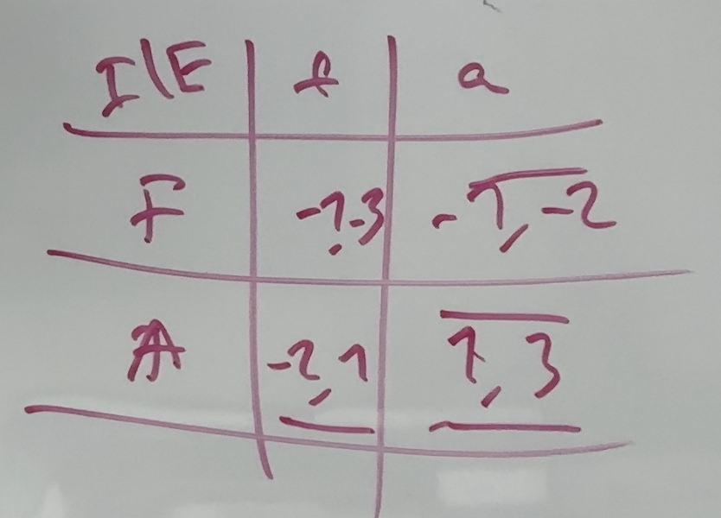
From whis we see that the only NE in $(A,a)$ giving utility $(3,1)$
From this we eliminate the 2 EQ $\left(\left(out,f\right),F\right) \left(\left(out,a\right),F\right)$
Since neither of them are NE in the subgame stated(I plays F)

We still need to check perfection in the complete game of this NE:
Since E gets his strictly highest payoff in this EQ we know that it is NE and thus SPNE
E chooses (3,1) over (0,2)
The only SPNE is $(\left(in,a\right),A)$

c.for $x≥0$
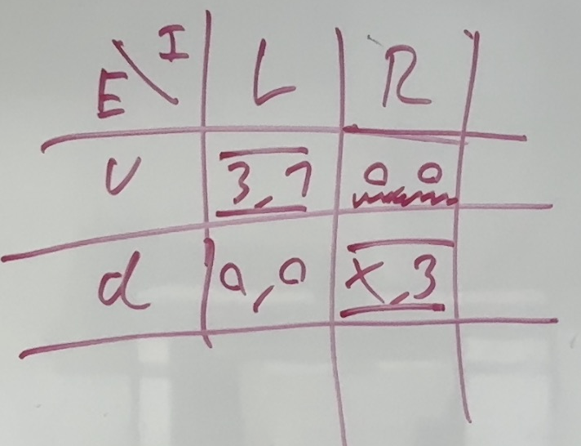
We have 2 NE $(u,L)(d,R)$
For $x<0$
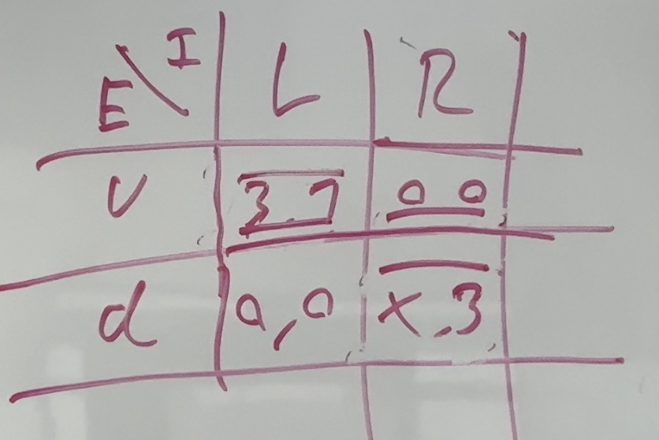

Only one NE in $(u,L)$

d. for $x≥0$
the (R,d) EQ
in the ”in” game E still strctly prefers a and thus I whould choose A thus we must have EQ in that subgame
we still have $x≥0$ thus it is again NE in the outer subgame
the arguments made in the ealier parts still hold making $(\left(in,a,d\right)\left(A,R\right))$

now the $(\left(in,a,u\right)\left(A,L\right))$ eq it holds for $x∈R$
it works in the ”A,a” subgame
and we have already shown that it works in the earlier parts since its just the game from the begining

Problem 2
A:
Im assuming were just looking at the EQ specified
A1
We must have $μ_{L}=1,μ_{H}=0$
A2
The expected retunr given beliefs becoes exactly the payoff we choose
Thus R must play $a_{L}{\left|m_{L},a_{H}\right|}_{H}$

For T to not want to deviate we need $x≥z,w≥y$ i simply check if these are satisfied
A3 $y>w$ gives incentive to deviate for T_H getting payoff y instead of w
Cannot exists!

A4 $z>x$ give T_L incentive to deviate to M_H meaning this cannot be an EQ

A5 this is just as i specified. There are no incentives to deviate and the EQ can then exist

b.
for any side set $μ_{other}=p$ then R chooses the same path giving him the exact same payoffs whatever it might be
if R makes the same choice on each side T will never have incentive to deviate since he has identical payoffs

c. the signal doesnt change anything about the payoff structure

Problem 3

- the pareto effecient allocation of workers is that everyone works who has
$$r\left(θ\right)≤θ$$
Or
$$Θ=\left\{θ:θ≥r\left(θ\right)=θ^{\frac{1}{4}} \right\}$$
For $θ∈[0,1]$ this is only true for $θ∈\{0,1\}$
$\{0,1\}$ should work
b. a firm is unable to observe types thus if they give a strictly higher wage all of lower type will ”act like” the higher type getting higher wage leading to negative profits for the firms

c.
i.
$$Θ\left(w\right)=\left\{θ:θ^{\frac{1}{4}}≤w\right\}=\left\{θ:θ≤w^{4}\right\}$$
ii.
$$E\left[θ | θ∈Θ\left(w\right)\right]=\frac{w^{4}}{2}$$

iii.
in any EQ we must have
$$w=E\left[θ | θ∈Θ\left(w\right)\right]=\frac{w^{4}}{2}$$
$$w=\frac{w^{4}}{2}$$
$⇕$ Ligningen løses for w vha. WordMat.
$$w=0 ∨ w=1,2599211$$
W=1.26 is not valid

Thus there is only one EQ with $w^{⋆}=0,Θ^{⋆}=\{0\}$
Wage is 0 and only the type 0 works
d. we have a theorem that states that the eq with the highest wage is constrined PE
thus the EQ
$$w^{⋆}=0,Θ^{⋆}=\{0\}$$
Must be constrained PE
Yes it actually is PE since no worker gets lower utility in this NE than in the First best
The only one who is not working who is working in the FB is $θ=1$
Who gets the exact same utility being $r\left(1\right)=1$

e.
the pareto effecient allocation of workers is that everyone works who has
$$r\left(θ\right)≤θ$$
Or
$$Θ=\left\{θ:θ≥r\left(θ\right)=θ^{4} \right\}=\left\{θ:1≥θ^{3} \right\}=[0,1]$$

f.
i
$$Θ\left(w\right)=\left\{θ:w≥θ^{4} \right\}=\left\{θ:w^{1/4}≥θ \right\}$$
ii
$$E\left[θ | θ∈Θ\left(w\right)\right]=\frac{w^{\frac{1}{4}}}{2}$$
Iii
Any EQ has
$$\frac{w^{\frac{1}{4}}}{2}=w$$
$⇕$ Ligningen løses for w vha. WordMat.
$$w=0 ∨ w=\frac{1}{2^{\frac{4}{3}}}$$
Yes there are 2 eq
$$w^{⋆}=0,Θ=\left\{0\right\}$$
$$w^{⋆}=\frac{1}{2^{\frac{4}{3}}},Θ^{⋆}=\left\{θ:θ^{4}≤\frac{1}{2^{\frac{4}{3}}}\right\}=[0,\frac{1}{2^{\frac{1}{3}}}]$$

g.
the EQ with the highest Wage is constrained PE
meaning that
$$w^{⋆}=\frac{1}{2^{\frac{4}{3}}},Θ^{⋆}=\left\{θ:θ^{4}≤\frac{1}{2^{\frac{4}{3}}}\right\}=[0,\frac{1}{2^{\frac{1}{3}}}]$$
Is Constrained Pareto efficient

Problem 4

$$V_{1}=200$$
$$G_{1}=25$$
$$V_{2}=75$$
$$G_{2}=15$$
$$I=110$$
a)
i)
$$V_{1}^{a}=V_{1}+G_{1}+I=200+25+110=335$$
$$V_{2}^{a}=V_{2}+G_{2}+I=75+15+110=200$$
ii) im assuming investors get a share of G
1:
$$E_{i}^{1}=\frac{I}{I+V_{1}}=\frac{110}{110+200}=\frac{11}{31}≈0,3548387$$
$$E_{s}^{1}=\frac{20}{31}$$

2:
$$E_{i}^{2}=\frac{I}{I+V_{2}}=\frac{110}{110+75}=\frac{22}{37}≈0,5945946$$
B:
I
Ii
Iii
iV
V

C:
I
Ii
Iii
iV

